Experiment 1

index.html
<!DOCTYPE html>
<html lang="en">
<head>
<meta charset="UTF-8">
<meta name="viewport" content="width=device-width, initial-scale=1.0">
<link rel="stylesheet" href="styles.css">
<title>Shopping Cart App</title>
</head>
<body>
<header>
<div class="logo">
<imgsrc="logo.png" alt="Logo" />
</div>
<h1>Welcome to Our Shopping Cart</h1>
<nav>
<a href="login.html">Login</a>
<a href="register.html">Register</a>
<a href="catalog.html">Catalog</a>
<a href="cart.html">Cart</a>
</nav>
</header>
<main>
<h2>Your one-stop shopping solution!</h2>
<p>Explore our catalog and start shopping today.</p>
</main>
<footer>
<p>&copy; 2025 Shopping Cart App</p>
<p>Follow us on
<a href="#">Facebook</a>
<a href="#">Twitter</a>
<a href="#">Instagram</a>
</p>
</footer>
</body>
</html>

login.html
<!DOCTYPE html>
<html lang="en">
<head>
<meta charset="UTF-8">
<meta name="viewport" content="width=device-width, initial-scale=1.0">
<link rel="stylesheet" href="https://cdnjs.cloudflare.com/ajax/libs/font-awesome/4.7.0/css/font-awesome.min.css">
<link rel="stylesheet" href="styles.css">
<title>Shopping Cart App</title>
</head>
<body>
<header>
<div class="logo">
<imgsrc="logo.png" alt="Logo" />
</div>
<h1>Welcome to Our Shopping Cart</h1>
<nav>
<a href="index.html">Home</a>
<a href="login.html" class="active">Login</a>
<a href="register.html">Register</a>
<a href="catalog.html">Catalog</a>
<a href="cart.html">Cart</a>
</nav>
</header>
<main>
<form class="form-container">
<input type="text" placeholder="Username" required>
<input type="password" placeholder="Password" required>
<button type="submit"class="gradient-button">Login</button>
<p>Don't have an account? <a href="register.html">Register here</a></p>
</form>
</main>
<footer>
<p>&copy; 2025 Shopping Cart App | Follow us on
<a href="#" class="fa fa-facebook"></a>
<a href="#" class="fa fa-twitter"></a>
<a href="#" class="fa fa-instagram"></a>
</p>
</footer>
</body>
</html>

register.html
<!DOCTYPE html>
<html lang="en">
<head>
<meta charset="UTF-8">
<meta name="viewport" content="width=device-width, initial-scale=1.0">
<link rel="stylesheet" href="https://cdnjs.cloudflare.com/ajax/libs/font-awesome/4.7.0/css/font-awesome.min.css">
<link rel="stylesheet" href="styles.css">
<title>Shopping Cart App</title>
</head>
<body>
<header>
<div class="logo">
<imgsrc="logo.png" alt="Logo" />
</div>
<h1>Welcome to Our Shopping Cart</h1>
<nav>
<a href="index.html">Home</a>
<a href="login.html">Login</a>
<a href="register.html" class="active">Register</a>
<a href="catalog.html">Catalog</a>
<a href="cart.html">Cart</a>
</nav>
</header>
<main>
<form class="form-container">
<input type="text" placeholder="Username" required>
<input type="email" placeholder="Email" required>
<input type="password" placeholder="Password" required>
<button type="submit" class="gradient-button">Register</button>
<p>Already have an account? <a href="login.html">Login here</a></p>
</form>
</main>
<footer>
<p>&copy; 2025 Shopping Cart App |
Follow us on
<a href="#" class="fa fa-facebook"></a>
<a href="#" class="fa fa-twitter"></a>
<a href="#" class="fa fa-instagram"></a>
</p>
</footer>
</body>
</html>
catalog.html
<!DOCTYPE html>
<html lang="en">
<head>
<meta charset="UTF-8">
<meta name="viewport" content="width=device-width, initial-scale=1.0">
<link rel="stylesheet" href="https://cdnjs.cloudflare.com/ajax/libs/font-awesome/4.7.0/css/font-awesome.min.css">
<link rel="stylesheet" href="styles.css">
<title>Shopping Cart App</title>
</head>
<body>
<header>
<div class="logo">
<imgsrc="logo.png" alt="Logo" />
</div>
<h1>Welcome to Our Shopping Cart</h1>
<nav>
<a href="index.html">Home</a>
<a href="login.html">Login</a>
<a href="register.html">Register</a>
<a href="catalog.html" class="active">Catalog</a>
<a href="cart.html">Cart</a>
</nav>
</header>
<main class="grid-container">
<div class="product">
<h2>Product 1</h2>
<p>Description of Product 1</p>
<button class="gradient-button">Add to Cart</button>
</div>
<div class="product">
<h2>Product 2</h2>
<p>Description of Product 2</p>
<button class="gradient-button">Add to Cart</button>
</div>
<div class="product">
<h2>Product 3</h2>
<p>Description of Product 3</p>
<button class="gradient-button">Add to Cart</button>
</div>
</main>
<footer>
<p>&copy; 2025 Shopping Cart App | Follow us on
<a href="#" class="fa fa-facebook"></a><a href="#" class="fa fa-twitter"></a>
<a href="#" class="fa fa-instagram"></a>
</p>
</footer>
</body>
</html>
cart.html
<!DOCTYPE html>
<html lang="en">
<head>
<meta charset="UTF-8">
<meta name="viewport" content="width=device-width, initial-scale=1.0">
<link rel="stylesheet" href="https://cdnjs.cloudflare.com/ajax/libs/font-awesome/4.7.0/css/font-awesome.min.css">
<link rel="stylesheet" href="styles.css">
<title>Shopping Cart App</title>
</head>
<body>
<header>
<div class="logo">
<imgsrc="logo.png" alt="Logo" />
</div>
<h1>Welcome to Our Shopping Cart</h1>
<nav>
<a href="index.html">Home</a>
<a href="login.html">Login</a>
<a href="register.html">Register</a>
<a href="catalog.html">Catalog</a>
<a href="cart.html" class="active">Cart</a>
</nav>
</header>
<main>
<div class="cart-item">
<h2>Product 1</h2>
<p>Quantity: 1</p>
<button class="gradient-button">Remove</button>
</div>
<div class="cart-item">
<h2>Product 2</h2>
<p>Quantity: 2</p>
<button class="gradient-button">Remove</button>
</div>
<button class="checkout">Checkout</button>
</main>
<footer>
<p>&copy; 2025 Shopping Cart App | Follow us on
<a href="#" class="fa fa-facebook"></a>
<a href="#" class="fa fa-twitter"></a>
<a href="#" class="fa fa-instagram"></a>
</p>
</footer>
</body>
</html>

styles.css
* {
box-sizing: border-box;
}
body {
font-family: Arial, sans-serif;
margin: 0;
padding: 0;
background-color: #f4f4f4;
}
header {
background: linear-gradient(135deg, #4CAF50 0%, #2E7D32 100%);
color: white;
padding: 20px 10px;
text-align: center;
position: relative;
}
.logoimg {
max-width: 90px; /* Adjust size as needed */
height: 90px;
position: absolute;
left: 20px;
top: 20px;
}
nav {
margin-top: 20px;
}
nav a {
margin: 0 15px;
color: white;
text-decoration: none;
font-weight: bold;
transition: color 0.3s;
}
nav a:hover {
color: #ffeb3b; /* Highlight color on hover */
}
/* Style for the active link */
nav .active {
color: #ffeb3b; /* Highlight color for the active link */
font-weight: bold;
border-bottom: 2px solid #ffeb3b; /* Underline effect */
padding-bottom: 5px; /* Space for underline */
}
main {
padding: 20px;
}
.form-container {
display: flex;
flex-direction: column;
max-width: 300px;
margin: auto;
}
.form-container input {
margin-bottom: 10px;
padding: 10px;
border: 1px solid #ccc;
border-radius: 5px;
}
.grid-container {
display: grid;
grid-template-columns: repeat(auto-fill, minmax(200px, 1fr));
gap: 20px;
}
.product, .cart-item {
border: 1px solid #ccc;
padding: 10px;
text-align: center;
border-radius: 5px;
transition: transform 0.2s;
}
.product:hover, .cart-item:hover {
transform: scale(.9); /* Slightly enlarge on hover */
box-shadow: 0 4px 8px rgba(0, 0, 0, 0.2);
}
.checkout {
display: block;
margin: 20px auto;
padding: 10px 20px;
background-color: #4CAF50;
color: white;
border: none;
cursor: pointer;
border-radius: 5px;
transition: background-color 0.3s;
}
/* Checkout Button Styles */
.checkout-container {
text-align: center; /* Center the button */
margin-top: 20px; /* Space above the button */
}
.checkout {
padding: 12px 24px; /* Vertical and horizontal padding */
font-size: 16px; /* Font size */
color: white; /* Text color */
background-color: #4CAF50; /* Button background color */
border: none; /* Remove default border */
border-radius: 5px; /* Rounded corners */
cursor: pointer; /* Pointer cursor on hover */
transition: background-color 0.3s, transform 0.2s; /* Smooth transition for background and scale */
}
/* Hover effect */
.checkout:hover {
background-color: #388E3C; /* Darker shade on hover */
transform: scale(1.05); /* Slightly enlarge on hover */
}
/* Active state */
.checkout:active {
transform: scale(0.95); /* Slightly shrink on click */
}
/* Focus state for accessibility */
.checkout:focus {
outline: none; /* Remove default outline */
box-shadow: 0 0 0 2px #ffeb3b; /* Add a custom focus outline */
}
.gradient-button {
padding: 12px 20px; /* Vertical and horizontal padding */
font-size: 16px; /* Font size */
color: white; /* Text color */
background: linear-gradient(90deg, #FF5733, #C70039); /* Gradient background */
border: none; /* Remove default border */
border-radius: 5px; /* Rounded corners */
cursor: pointer; /* Pointer cursor on hover */
transition: background 0.3s, transform 0.2s; /* Smooth transition for background and scale */
}
/* Hover effect */
.gradient-button:hover {
background: linear-gradient(90deg, #C70039, #FF5733); /* Reverse gradient on hover */
transform: scale(1.05); /* Slightly enlarge on hover */
}
/* Active state */
.gradient-button:active {
transform: scale(0.95); /* Slightly shrink on click */
}
/* Focus state for accessibility */
.gradient-button:focus {
outline: none; /* Remove default outline */
box-shadow: 0 0 0 3px rgba(255, 87, 51, 0.5); /* Add a custom focus outline */
}
.fa {
padding: 20px;
font-size: 30px;
width: 70px;
text-align: center;
text-decoration: none;
margin: 5px 2px;
border-radius:100%;
}
.fa:hover {
opacity: 0.7;
}
.fa-facebook {
background: #3B5998;
color: white;
}
.fa-twitter {
background: #55ACEE;
color: white;
}
.fa-instagram {
background: #125688;
color: white;
}
footer {
background-color: #333;
color: white;
text-align: center;
padding: 20px;
position: relative;
bottom: 0;
width: 100%;
}
footer p {
margin: 5px 0;
}
footer a {
color: #ffeb3b; /* Highlight color for links */
text-decoration: none;
transition: color 0.3s;
}
footer a:hover {
color: #fff; /* Change color on hover */
}

Experiment 2:

Step 1: Include Bootstrap
First, you need to include Bootstrap in your HTML. You can use a CDN for quick setup. Add this within the <head> section of all HTML files:
html
<!DOCTYPE html>
<html lang="en">
<head>
<meta charset="UTF-8">
<meta name="viewport" content="width=device-width, initial-scale=1.0">
<title>Shopping Cart</title>
<link rel="stylesheet" href="https://stackpath.bootstrapcdn.com/bootstrap/4.5.2/css/bootstrap.min.css">
<link rel="stylesheet" href="styles.css"><!-- Your custom styles -->
</head>
<body>
Step 2: Create a Responsive Layout
Here is the procedure how to structure your shopping cart application using Bootstrap's grid system and components:
HTML Structure
<body>
<div class="container mt-5">
<h1 class="text-center">Shopping Cart</h1>
<div class="row">
<div class="col-md-8">
<div class="card">
<div class="card-header">
<h5>Your Items</h5>
</div>
<div class="card-body">
<!-- Example item -->
<div class="row my-3">
<div class="col-6">
<h6>Product Name</h6>
<p>Price: $10.00</p>
</div>
<div class="col-6 text-right">
<button class="btnbtn-primary flat-button">Add to Cart</button>
</div>
</div>
<!-- Add more products as needed -->
</div>
</div>
</div>
<div class="col-md-4">
<div class="card">
<div class="card-header">
<h5>Checkout</h5>
</div>
<div class="card-body text-center">
<button class="btnbtn-danger gradient-button">Checkout Now</button>
</div>
</div>
</div>
</div>
</div>

<script src="https://code.jquery.com/jquery-3.5.1.slim.min.js"></script>
<script src="https://cdn.jsdelivr.net/npm/@popperjs/core@2.9.2/dist/umd/popper.min.js"></script>
<script src="https://stackpath.bootstrapcdn.com/bootstrap/4.5.2/js/bootstrap.min.js"></script>
</body>
Step 3: Update CSS Styles
You can keep the previous CSS styles for your buttons in a separate styles.css file. Here’s how you might update it to ensure compatibility with Bootstrap:
styles.css
/* Flat Button Styles */
.flat-button {
padding: 12px 20px; /* Vertical and horizontal padding */
font-size: 16px; /* Font size */
color: white; /* Text color */
background-color: #007BFF; /* Button background color */
border: none; /* Remove default border */
border-radius: 5px; /* Rounded corners */
cursor: pointer; /* Pointer cursor on hover */
transition: background-color 0.3s, transform 0.2s; /* Smooth transition for background and scale */
}
/* Hover effect */
.flat-button:hover {
background-color: #0056b3; /* Darker shade on hover */
transform: scale(1.05); /* Slightly enlarge on hover */
}
/* Active state */
.flat-button:active {
transform: scale(0.95); /* Slightly shrink on click */
}
/* Focus state for accessibility */
.flat-button:focus {
outline: none; /* Remove default outline */
box-shadow: 0 0 0 3px rgba(0, 123, 255, 0.5); /* Add a custom focus outline */
}
/* Gradient Button Styles */
.gradient-button {
padding: 12px 20px; /* Vertical and horizontal padding */
font-size: 16px; /* Font size */
color: white; /* Text color */
background: linear-gradient(90deg, #FF5733, #C70039); /* Gradient background */
border: none; /* Remove default border */
border-radius: 5px; /* Rounded corners */
cursor: pointer; /* Pointer cursor on hover */
transition: background 0.3s, transform 0.2s; /* Smooth transition for background and scale */
}
/* Hover effect */
.gradient-button:hover {
background: linear-gradient(90deg, #C70039, #FF5733); /* Reverse gradient on hover */
transform: scale(1.05); /* Slightly enlarge on hover */
}
/* Active state */
.gradient-button:active {
transform: scale(0.95); /* Slightly shrink on click */
}
/* Focus state for accessibility */
.gradient-button:focus {
outline: none; /* Remove default outline */
box-shadow: 0 0 0 3px rgba(255, 87, 51, 0.5); /* Add a custom focus outline */
}

Experiment 3

register.html
<!DOCTYPE html>
<html lang="en">
<head>
<meta charset="UTF-8">
<meta name="viewport" content="width=device-width, initial-scale=1.0">
<link rel="stylesheet" href="https://cdnjs.cloudflare.com/ajax/libs/font-awesome/4.7.0/css/font-awesome.min.css">
<link rel="stylesheet" href="styles.css">
<link rel="stylesheet" href="https://stackpath.bootstrapcdn.com/bootstrap/4.5.2/css/bootstrap.min.css">

<title>Shopping Cart App</title>

<script src="script.js"></script>
</head>
<body>
<header>
<div class="logo">
<imgsrc="logo.png" alt="Logo" />
</div>
<h1>Welcome to Our Shopping Cart</h1>
<nav>
<a href="index.html">Home</a>
<a href="login.html">Login</a>
<a href="register.html" class="active">Register</a>
<a href="catalog.html">Catalog</a>
<a href="cart.html">Cart</a>
</nav>
</header>
<main>

<input type="text" placeholder="Username" id="username"><br>
<input type="email" placeholder="Email"><br>
<input type="password" placeholder="Password" id="password"><br>
<button type="submit" class="gradient-button" onclick="check()">Register</button>
<p>Already have an account? <a href="login.html">Login here</a></p>

</main>
<footer>
<p>&copy; 2025 Shopping Cart App |
Follow us on
<a href="#" class="fa fa-facebook"></a>
<a href="#" class="fa fa-twitter"></a>
<a href="#" class="fa fa-instagram"></a>
</p>
</footer>
</body>
</html>

login.html
<body>
<header>
<div class="logo">
<imgsrc="logo.png" alt="Logo" />
</div>
<h1>Welcome to Our Shopping Cart</h1>
<nav>
<a href="index.html">Home</a>
<a href="login.html" class="active">Login</a>
<a href="register.html">Register</a>
<a href="catalog.html">Catalog</a>
<a href="cart.html">Cart</a>
</nav>
</header>
<main>
<form class="form-container">
<input type="text" placeholder="Username" id="username"> <br>
<input type="password" placeholder="Password" id="password"><br>
<button type="submit"class="gradient-button" onclick="check()">Login</button>
<p>Don't have an account? <a href="register.html">Register here</a></p>
</form>
</main>
<footer>
<p>&copy; 2025 Shopping Cart App | Follow us on
<a href="#" class="fa fa-facebook"></a>
<a href="#" class="fa fa-twitter"></a>
<a href="#" class="fa fa-instagram"></a>
</p>
</footer>

</body>

script.js
function check(){
const user = document.getElementById("username").value
const pswd = document.getElementById("password").value
if(user.length<6){
alert("need to enter username greater than 6")
}
if(pswd.length<6){
alert("Enter password greater than 6")

}
}

Experiment 4

index.html
<!DOCTYPE html>
<html lang="en">
<head>
<meta charset="UTF-8">
<meta name="viewport" content="width=device-width, initial-scale=1.0">
<link rel="stylesheet" href="https://stackpath.bootstrapcdn.com/bootstrap/4.5.2/css/bootstrap.min.css">
<title>Weather App</title>
<link rel="stylesheet" href="https://stackpath.bootstrapcdn.com/bootstrap/4.5.2/css/bootstrap.min.css">
<script src="https://cdn.jsdelivr.net/npm/chart.js"></script>
</head>
<body>
<div class="container mt-5">
<h1 class="text-center">Weather Information</h1>
<div class="form-group">
<label for="city">Enter City Name:</label>
<input type="text" id="cityInput" class="form-control" placeholder="City Name">
<button onclick="getWeather()" class="btnbtn-primary mt-3">Get Weather</button>
</div>
<div>
<h2>Weather Results:</h2>
<pre style="font-size:16pt; border: 2px solid aqua;
border-radius: 5px; padding:5px;font-family:cambria"id="weatherResult"></pre>
</div>
</div>
<script src="script.js"></script>
</body>
</html>
Step 2: Create the JavaScript File
script.js
// Replace with your OpenWeatherMap API key
const apiKey = "f6dc4f4e7b873301bc6afaeb13e4ea58";
async function getWeather() {
const city = document.getElementById("cityInput").value;
const weatherResult = document.getElementById("weatherResult");
if (!city) {
weatherResult.textContent = "Please enter a city name.";
return;
}
try {
const response = await fetch(
`https://api.openweathermap.org/data/2.5/weather?q=${city}&appid=${apiKey}`
);
const data = await response.json();
if (data.cod === 200) {
const weather = data.weather[0].description;
const temperature = (data.main.temp - 273.15).toFixed(2); // Convert Kelvin to Celsius
weatherResult.textContent = `Weather: ${weather}\nTemperature: ${temperature}°C`;
} else {
weatherResult.textContent = `Error: ${data.message}`;
}
} catch (error) {
weatherResult.textContent = `Error fetching weather data: ${error.message}`;
}
}

Experiment 5

Database creation
CREATE DATABASE shopping_cart;
Open Database
USE shopping_cart;
Create Products Table
CREATE TABLE products (
id INT AUTO_INCREMENT PRIMARY KEY,
name VARCHAR(255) NOT NULL,
price DECIMAL(10, 2) NOT NULL,
quantity INT NOT NULL
);
Step 3: Create the Java Application
1. Create a Java Project: Create a new Java project in your IDE (like IntelliJ IDEA or Eclipse).
2. Add MySQL Connector: Ensure that the MySQL JDBC driver is added to your project's libraries.

Step 4: Implement the CRUD Operations
Main.java
import java.sql.*;
import java.util.Scanner;
public class Main {
private static final String URL = "jdbc:mysql://localhost:3306/shopping_cart";
private static final String USER = "root"; // Your MySQL username
private static final String PASSWORD = "password"; // Your MySQL password
public static void main(String[] args) {
try (Connection connection = DriverManager.getConnection(URL, USER, PASSWORD)) {
Scanner scanner = new Scanner(System.in);
int choice;
do {
System.out.println("1. Add Product");
System.out.println("2. View Products");
System.out.println("3. Update Product");
System.out.println("4. Delete Product");
System.out.println("5. Exit");
System.out.print("Enter your choice: ");
choice = scanner.nextInt();
scanner.nextLine(); // Consume newline
switch (choice) {
case 1:
addProduct(connection, scanner);
break;
case 2:
viewProducts(connection);
break;
case 3:
updateProduct(connection, scanner);
break;
case 4:
deleteProduct(connection, scanner);
break;
case 5:
System.out.println("Exiting...");
break;
default:
System.out.println("Invalid choice. Please try again.");
}
} while (choice != 5);
} catch (SQLException e) {
e.printStackTrace();
}
}
private static void addProduct(Connection connection, Scanner scanner) throws SQLException {
System.out.print("Enter product name: ");
String name = scanner.nextLine();
System.out.print("Enter product price: ");
double price = scanner.nextDouble();
System.out.print("Enter product quantity: ");
int quantity = scanner.nextInt();
String sql = "INSERT INTO products (name, price, quantity) VALUES (?, ?, ?)";
try (PreparedStatement statement = connection.prepareStatement(sql)) {
statement.setString(1, name);
statement.setDouble(2, price);
statement.setInt(3, quantity);
statement.executeUpdate();
System.out.println("Product added successfully.");
}
}
private static void viewProducts(Connection connection) throws SQLException {
String sql = "SELECT * FROM products";
try (Statement statement = connection.createStatement();
ResultSetresultSet = statement.executeQuery(sql)) {
System.out.println("Products in the Shopping Cart:");
while (resultSet.next()) {
System.out.println("ID: " + resultSet.getInt("id") +
", Name: " + resultSet.getString("name") +
", Price: " + resultSet.getDouble("price") +
", Quantity: " + resultSet.getInt("quantity"));
}
}
}
private static void updateProduct(Connection connection, Scanner scanner) throws SQLException {
System.out.print("Enter product ID to update: ");
int id = scanner.nextInt();
scanner.nextLine(); // Consume newline
System.out.print("Enter new product name: ");
String name = scanner.nextLine();
System.out.print("Enter new product price: ");
double price = scanner.nextDouble();
System.out.print("Enter new product quantity: ");
int quantity = scanner.nextInt();
String sql = "UPDATE products SET name = ?, price = ?, quantity = ? WHERE id = ?";
try (PreparedStatement statement = connection.prepareStatement(sql)) {
statement.setString(1, name);
statement.setDouble(2, price);
statement.setInt(3, quantity);
statement.setInt(4, id);
int rowsUpdated = statement.executeUpdate();
if (rowsUpdated> 0) {
System.out.println("Product updated successfully.");
} else {
System.out.println("Product not found.");
}
}
}
private static void deleteProduct(Connection connection, Scanner scanner) throws SQLException {
System.out.print("Enter product ID to delete: ");
int id = scanner.nextInt();
String sql = "DELETE FROM products WHERE id = ?";
try (PreparedStatement statement = connection.prepareStatement(sql)) {
statement.setInt(1, id);
int rowsDeleted = statement.executeUpdate();
if (rowsDeleted> 0) {
System.out.println("Product deleted successfully.");
} else {
System.out.println("Product not found.");
}
}
}
}

Step 5:Running the Application
1. Compile and Run: Compile and run the Main.java file in your IDE or command line.
2. Perform CRUD Operations: Follow the prompts to add, view, update, or delete products in the shopping cart.

Output
Enter The choice from below options
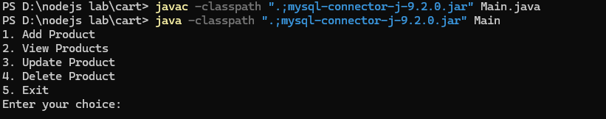
Selected Option 2 to view products
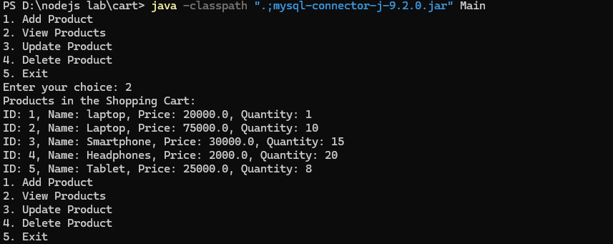

Experiment 6
bookstore.xml
<?xml version="1.0" encoding="UTF-8"?>
<!DOCTYPE bookstore SYSTEM "bookstore.dtd">
<bookstore xmlns:xsi="http://www.w3.org/2001/XMLSchema-instance"
xsi:noNamespaceSchemaLocation="bookstore.xsd">
<book>
<title>The Great Gatsby</title>
<author>F. Scott Fitzgerald</author>
<price>10.99</price>
<genre>Fiction</genre>
<publish_date>1925-04-10</publish_date>
</book>
<book>
<title>1984</title>
<author>George Orwell</author>
<price>9.99</price>
<genre>Dystopian</genre>
<publish_date>1949-06-08</publish_date>
</book>
<book>
<title>To Kill a Mockingbird</title>
<author>Harper Lee</author>
<price>7.99</price>
<genre>Fiction</genre>
<publish_date>1960-07-11</publish_date>
</book>
</bookstore>
bookstore.dtd
<!ELEMENT bookstore (book+)>
<!ELEMENT book (title, author, price, genre, publish_date)>
<!ELEMENT title (#PCDATA)>
<!ELEMENT author (#PCDATA)>
<!ELEMENT price (#PCDATA)>
<!ELEMENT genre (#PCDATA)>
<!ELEMENT publish_date (#PCDATA)>
bookstore.xsd
<?xml version="1.0" encoding="UTF-8"?>
<xs:schemaxmlns:xs="http://www.w3.org/2001/XMLSchema">

<xs:element name="bookstore">
<xs:complexType>
<xs:sequence>
<xs:element name="book" maxOccurs="unbounded">
<xs:complexType>
<xs:sequence>
<xs:element name="title" type="xs:string"/>
<xs:element name="author" type="xs:string"/>
<xs:element name="price" type="xs:decimal"/>
<xs:element name="genre" type="xs:string"/>
<xs:element name="publish_date" type="xs:date"/>
</xs:sequence>
</xs:complexType>
</xs:element>
</xs:sequence>
</xs:complexType>
</xs:element>
</xs:schema>

Step 2: Create Java file to validate XML against XSD and DTD
import org.w3c.dom.Document;
import org.xml.sax.SAXException;
import javax.xml.XMLConstants;
import javax.xml.parsers.DocumentBuilder;
import javax.xml.parsers.DocumentBuilderFactory;
import javax.xml.validation.Schema;
import javax.xml.validation.SchemaFactory;
import javax.xml.validation.Validator;
import javax.xml.parsers.ParserConfigurationException;
import javax.xml.transform.stream.StreamSource;
import java.io.File;
import java.io.IOException;
public class ValidateXML {
//Validating XML XSD Method
public static void validateXSD(){
try {
// Validate against XSD
SchemaFactoryschemaFactory = SchemaFactory.newInstance(XMLConstants.W3C_XML_SCHEMA_NS_URI);
Schema schema = schemaFactory.newSchema(new File("bookstore.xsd"));
Validator validator = schema.newValidator();
validator.validate(new StreamSource(new File("bookstore.xml")));
System.out.println("XML is valid against XSD.");
} catch (SAXException e) {
System.err.println("XML is NOT valid against XSD: " + e.getMessage());
} catch (IOException e) {
System.err.println("Error reading XML or XSD file: " + e.getMessage());
}
}
//Validating XML DTD Method
public static void validateDTD(){
try {

// Load the XML file
File xmlFile = new File("bookstore.xml");
File dtdFile = new File("bookstore.dtd");
// Create a DocumentBuilderFactory
DocumentBuilderFactory factory = DocumentBuilderFactory.newInstance();
factory.setValidating(true); // Enable validation
factory.setNamespaceAware(true);
factory.setAttribute("http://java.sun.com/xml/jaxp/properties/schemaLanguage", "http://www.w3.org/2001/XMLSchema"); // Set schema language
// Create a DocumentBuilder
DocumentBuilder builder = factory.newDocumentBuilder();

// Parse the XML file
Document document = builder.parse(xmlFile);
// Validate against DTD
System.out.println("XML is valid against DTD.");
} catch (ParserConfigurationException e) {
System.err.println("Parser configuration error: " + e.getMessage());
} catch (SAXException e) {
System.err.println("XML is NOT valid: " + e.getMessage());
} catch (IOException e) {
System.err.println("I/O error: " + e.getMessage());
}
}
public static void main(String[] args) {
System.out.println("VALIDATING XML XSD......");
validateXSD();
System.out.println("------------------------");
System.out.println("VALIDATING XML DTD......");
validateDTD();
}
}

Step 3: Compile and run ValidateXML.java file to view the results

Output:

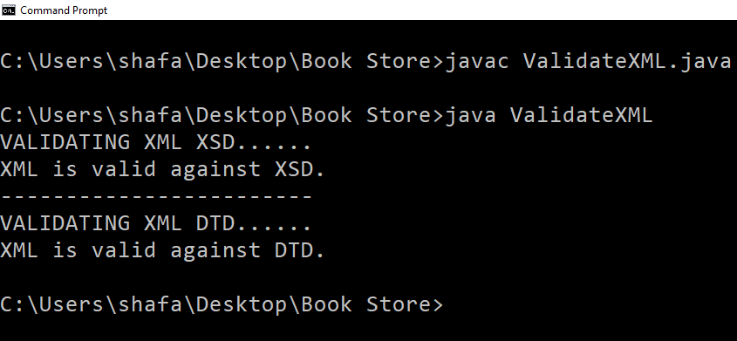

Experiment 9

server.js
const http = require("http");
const os = require("os");
const path = require("path");
const EventEmitter = require("events");

// Create a custom event emitter
const eventEmitter = new EventEmitter();
// Create an HTTP server
const server = http.createServer((req, res) => {
if (req.url === "/") {
res.writeHead(200, { "Content-Type": "text/plain" });
res.end("Welcome to the Node.js Server!");
} else if (req.url === "/os") {
res.writeHead(200, { "Content-Type": "text/plain" });
res.end(`OS Info: ${os.type()} ${os.release()}`);
} else if (req.url === "/path") {
const filePath = path.join(__dirname, "server.js");
res.writeHead(200, { "Content-Type": "text/plain" });
res.end(`File Path: ${filePath}`);
} else if (req.url === "/event") {
eventEmitter.on("greet", () => {
res.writeHead(200, { "Content-Type": "text/plain" });
res.end("Event Emitted: Hello World!");
});
eventEmitter.emit("greet");
} else {
res.writeHead(404, { "Content-Type": "text/plain" });
res.end("404 Not Found");
}
});
// Start the server
const PORT = 3000;
server.listen(PORT, () => {
console.log(`Server is running on http://localhost:${PORT}`);
});
How to Run:
Run the server using the command:
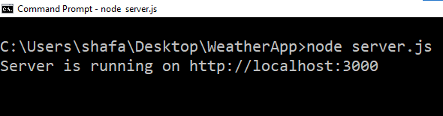

Open your browser and visit:
http://localhost:3000for the welcome message.
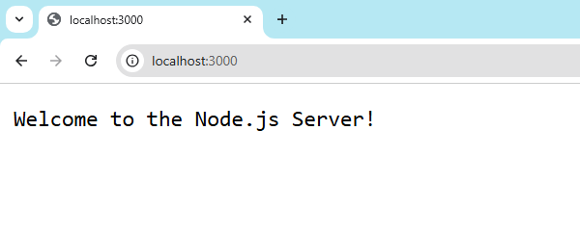
http://localhost:3000/osfor OS information and http://localhost:3000/pathfor the file path.
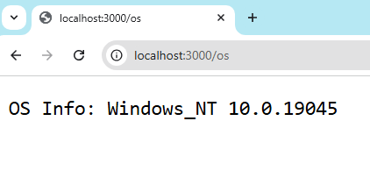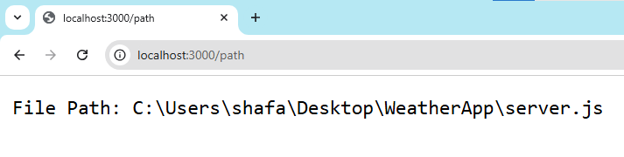

http://localhost:3000/eventto trigger an event.
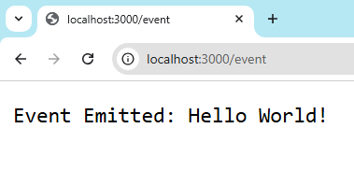
http://localhost:3000/component -- component is not a nodejs module
